Green Party

A short version of the Green Party manifesto 2026
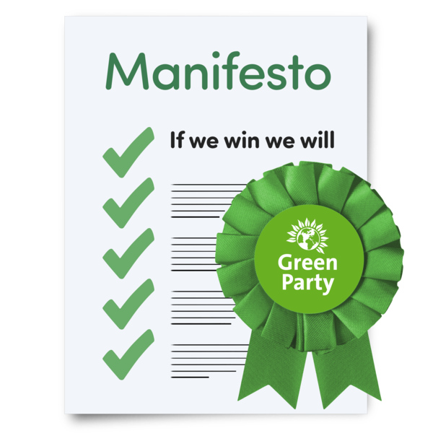

Easy Read

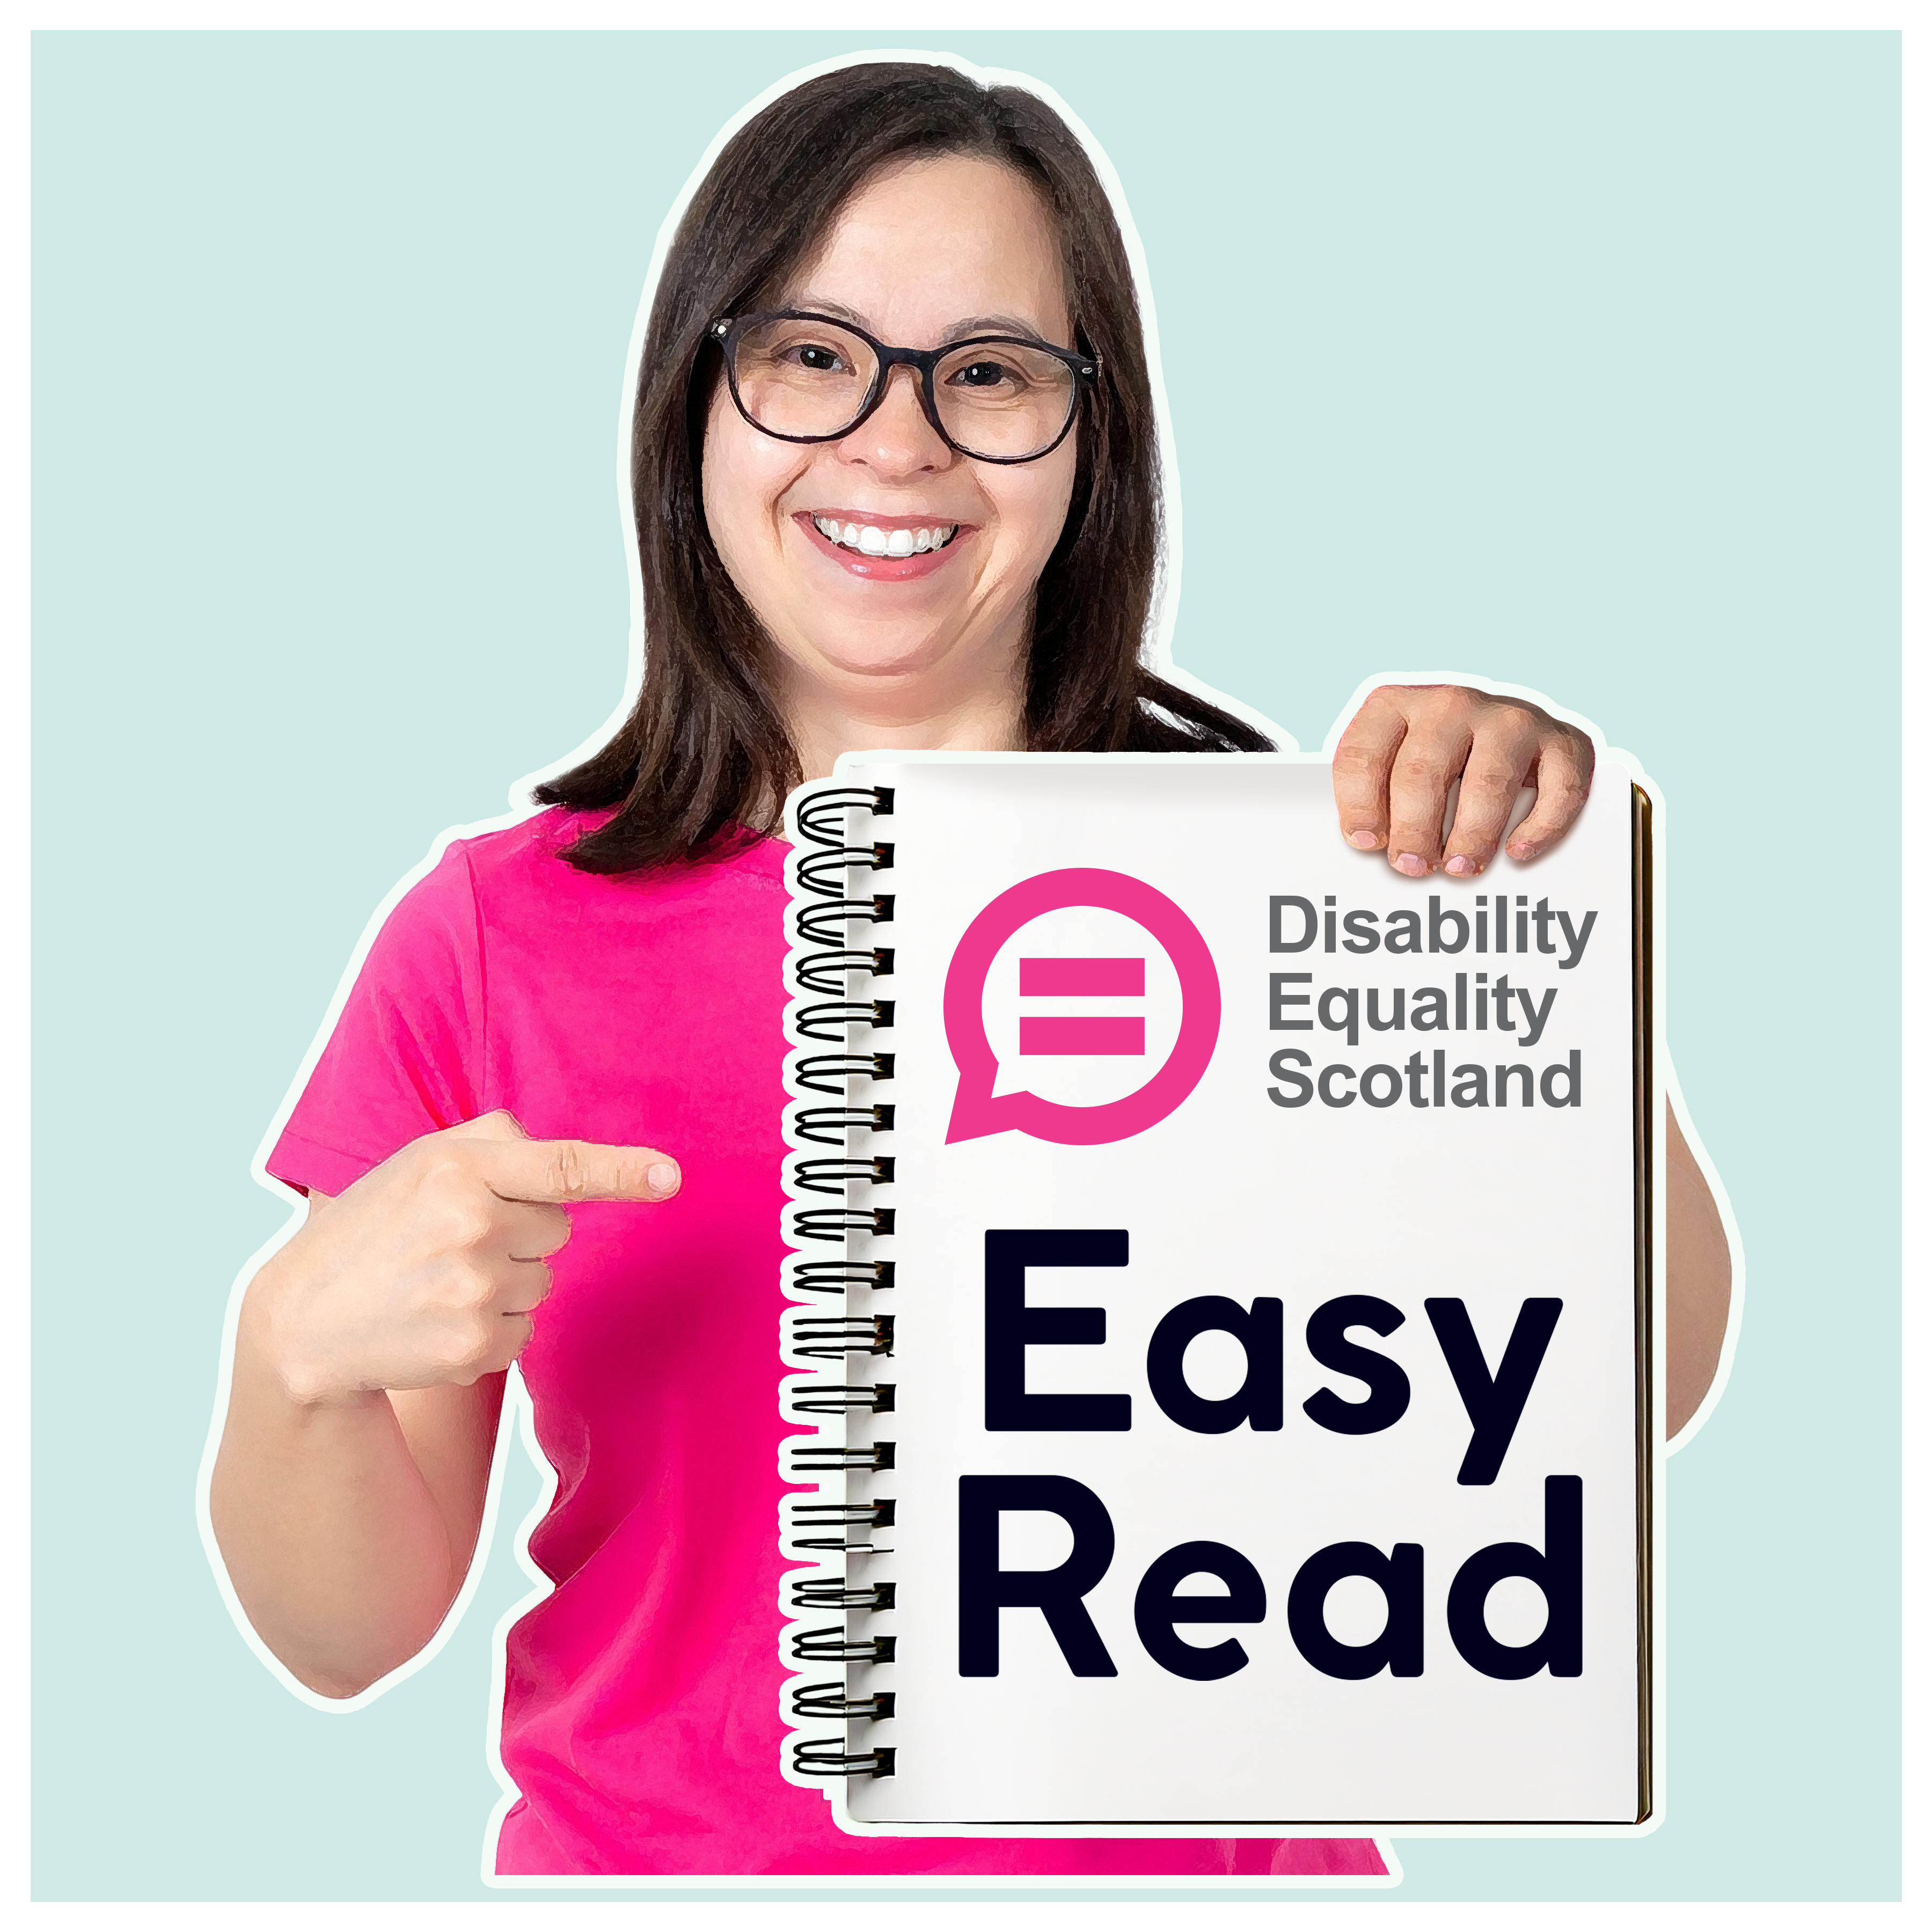

What this document is about

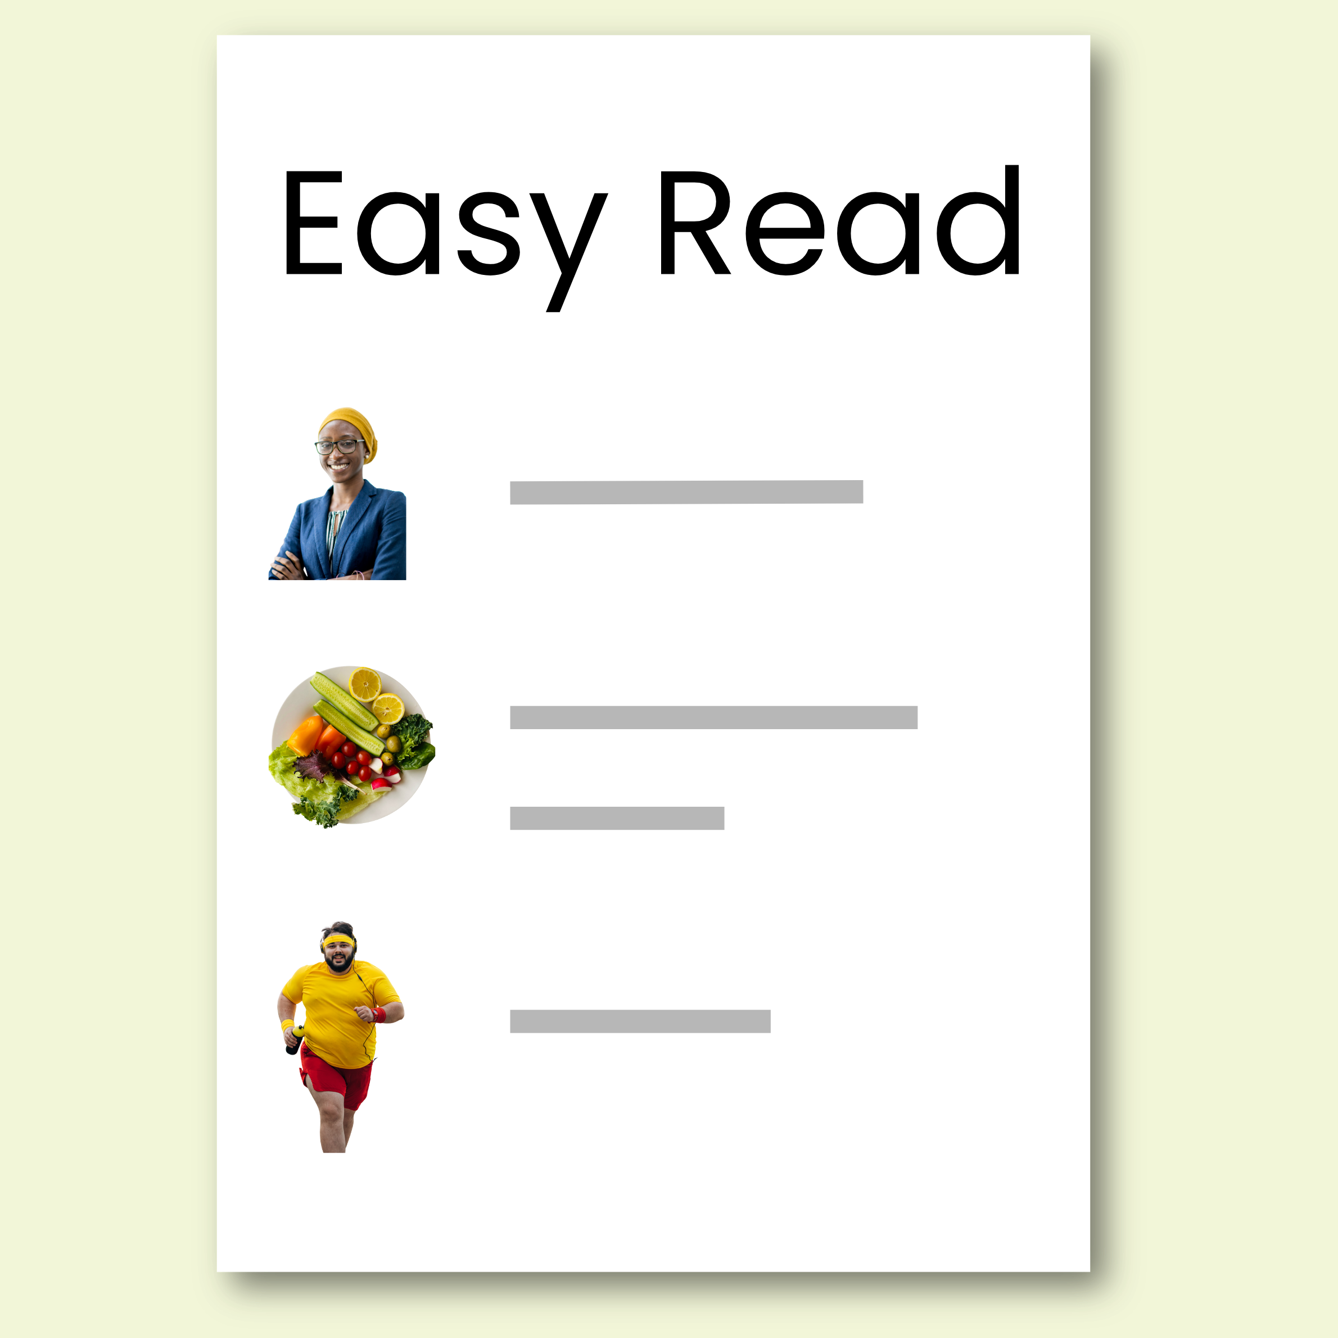 | This is an Easy Read document written by the Green Party.
 | It is a short version of our manifesto – this means a plan about what the Green Party believe in and what work we want to do.  This document tells you about our most important work.  We call this our priorities.

Our priorities

  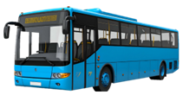 | - free bus travel for everyone in Scotland
 | - funded childcare hours for every child in Scotland from 6 months up  In this document funded means it is paid for by the Scottish Government.
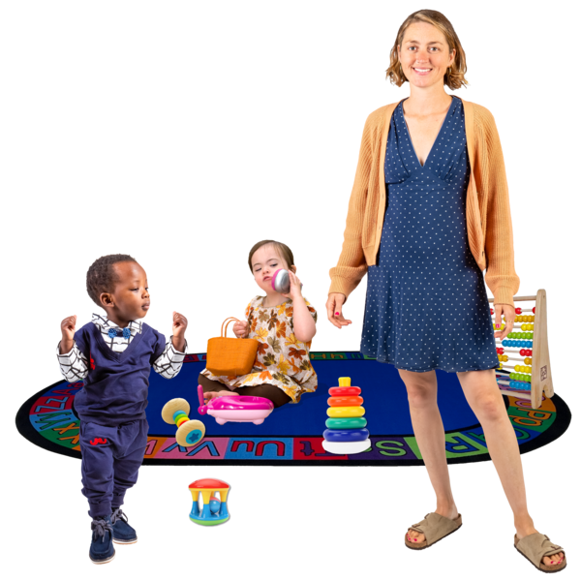  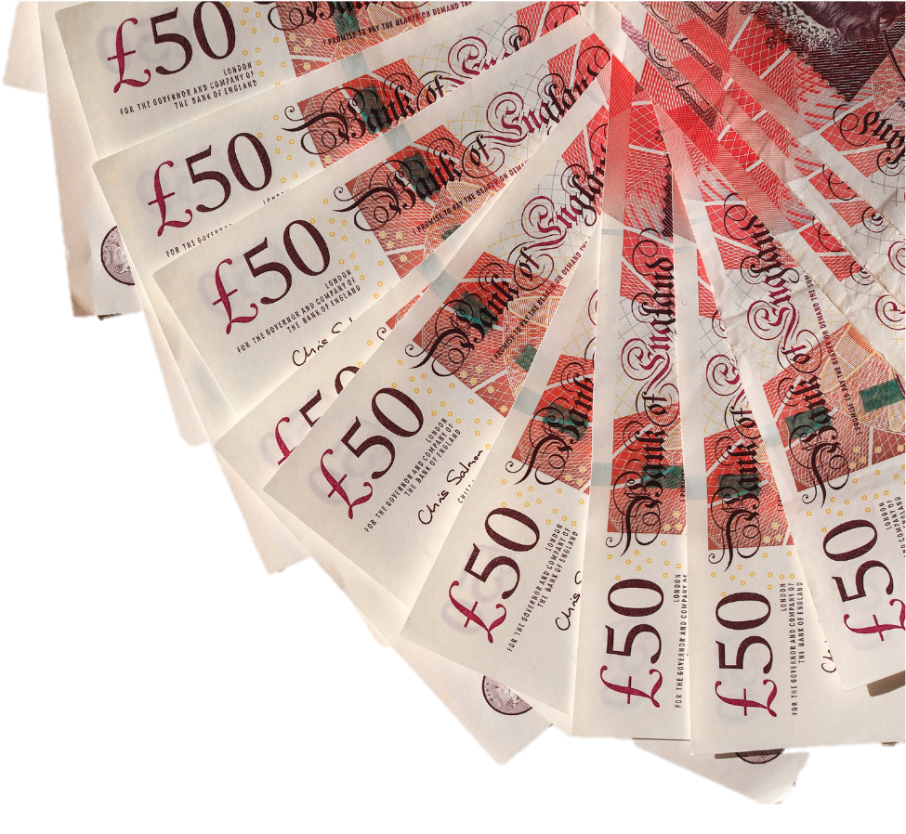 | - put more money into nurseries and childminders so there are more funded places available for every family
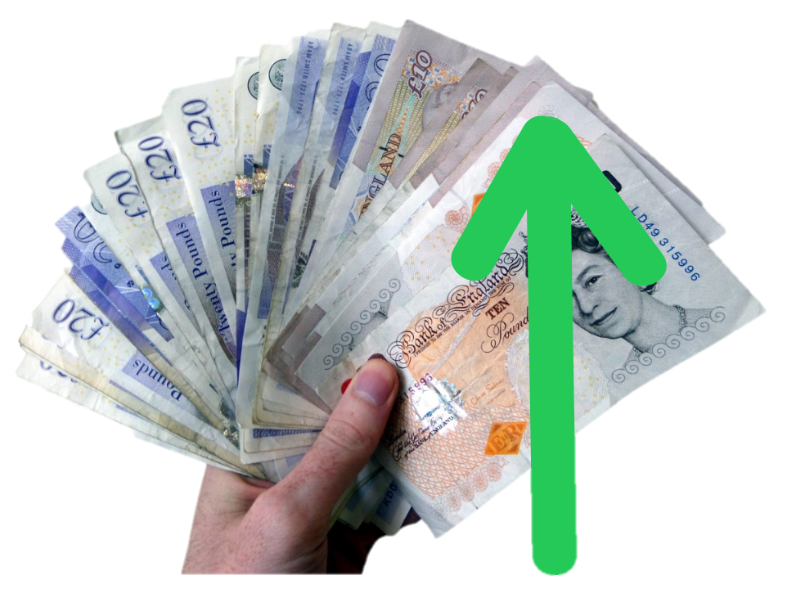 | - tax people who have a lot of money  - tax industries that cause pollution and emissions
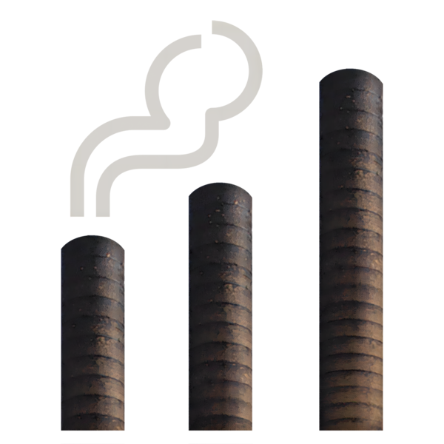 | Pollution and emissions mean things that have been put into the environment that are bad for our health.
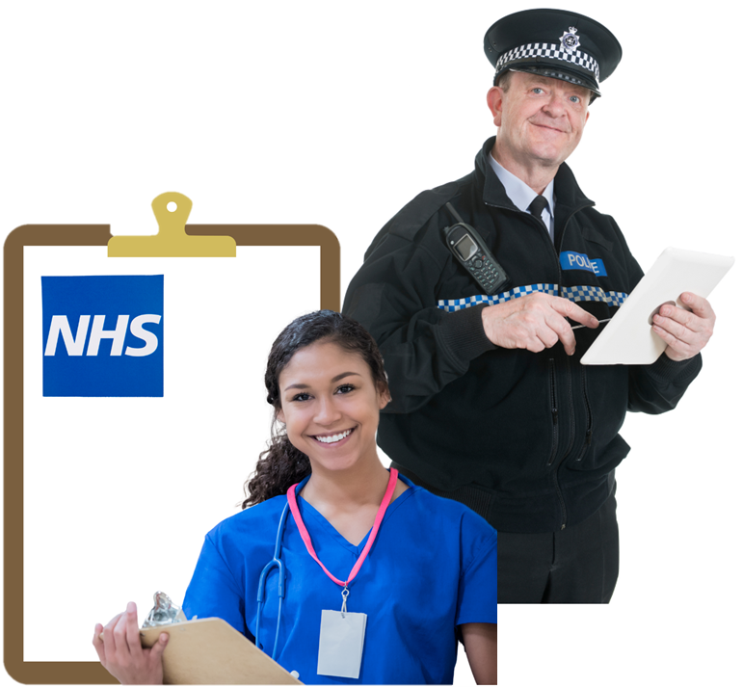 | The money we get from these taxes would pay for the public services we all need.
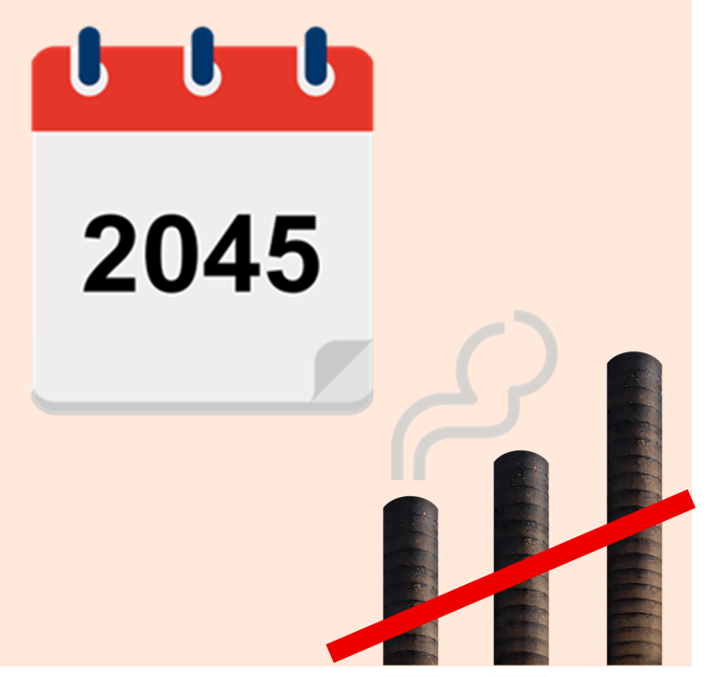 | - make sure that Scotland will have net zero emissions by 2045  Net zero means having as few emissions put into the air as we can.
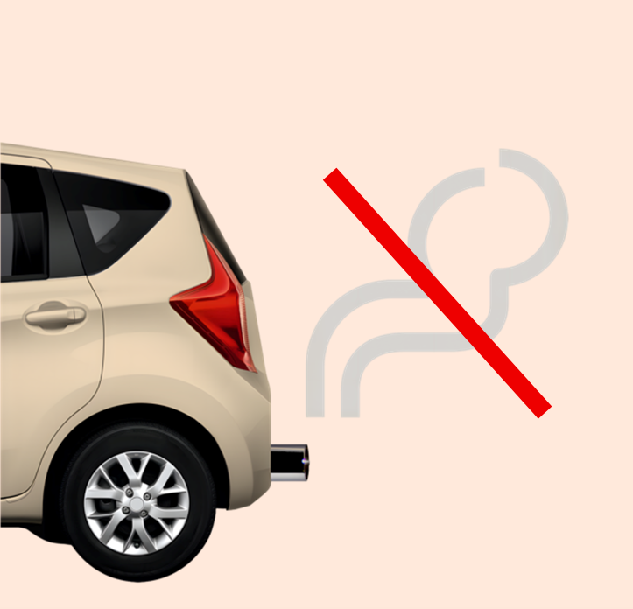 | We want to work to have less emissions from transport, energy, farming and housing.
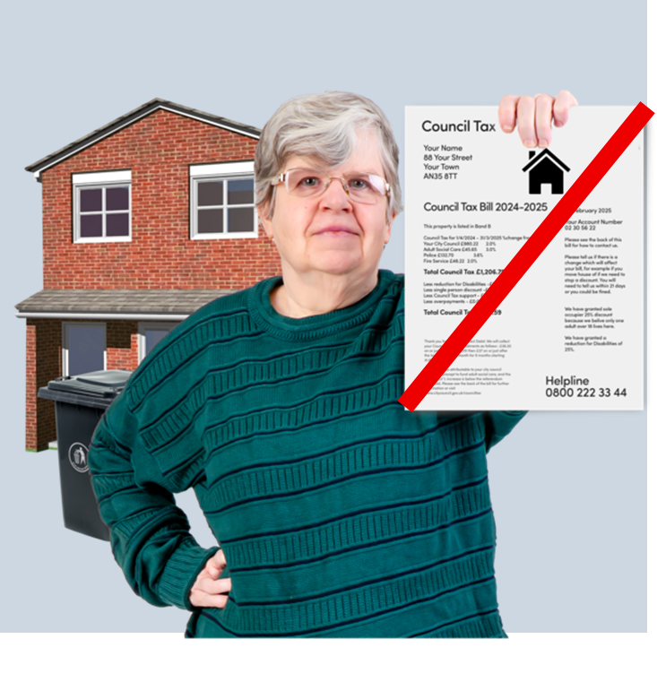 | - get rid of Council Tax and replace it with a fairer Residential Property Tax to support the local services we all need
